Welcome to 4th Grade 2024 – 2025

Welcome!

4th grade will be an amazing learning year for your child. Virtually, we will explore all about our beautiful state and its people. We will share wonderous places in Nevada for you to visit as a family! Below please find the list of supplies to help our classroom and your child be prepared each day for learning. Thank you so very much for providing these items for your child. Thank you in advance to our families who provide extra items for others—that is so beyond generous and kind and always so appreciated! Thank you!

If you have any questions or concerns, please do not hesitate to reach out.

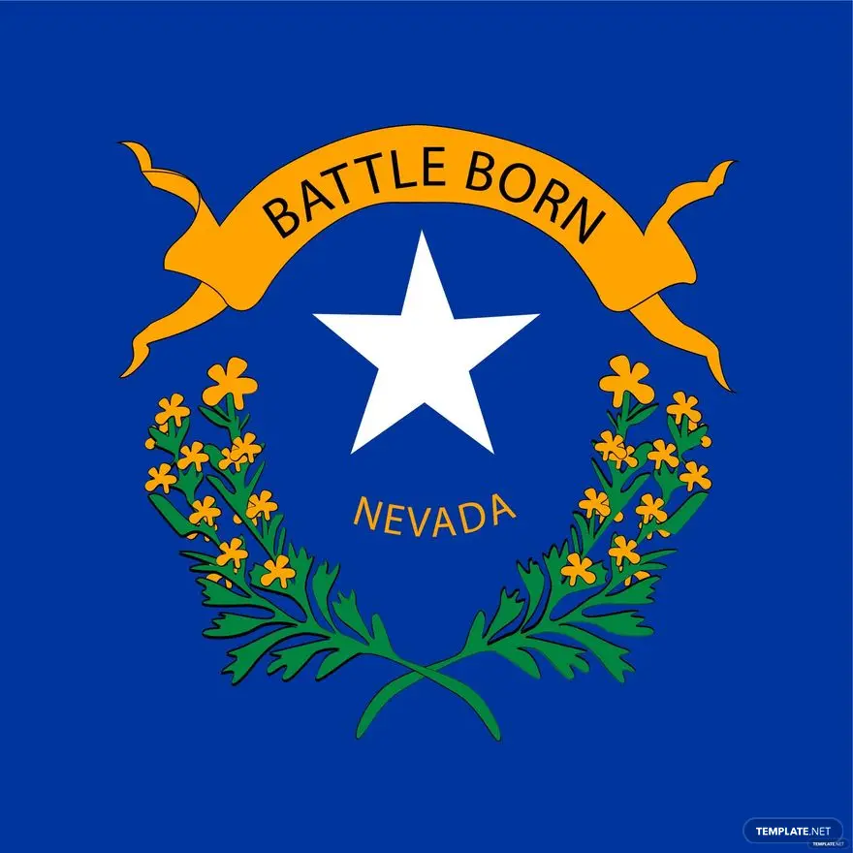

* 1 flat rock approximately 4 inches in diameter (for an art project)
* 60 pre-sharpened Ticonderoga pencils (They truly last!)
* 4 black sharpies fine point (please, not ultra-fine point)
* 2 yellow highlighters please
* 4 black dry erase markers
* 2 large glue sticks
* 1 box of colored pencils
* 1 pair of scissors for intermediate age students
* 1 heavy duty ruler with both centimeters and inches
* 1 pencil box
* 1 heavy-duty folder to be used for daily home/school communication
* 2 Clorox wipe containers (A to L Last Names, please purchase these items)
* 2 boxes of tissues (M to Z Last Names, please purchase these items.)
* $25. Class fee made payable to Verdi Elementary School, please, to purchase art supplies and/or additional classroom supplies.

Wishing you a summer filled with EXCITING adventures.

😊 4th Grade Teachers